Lonely Shades - Silicon Valley International Contemporary Art Exhibition

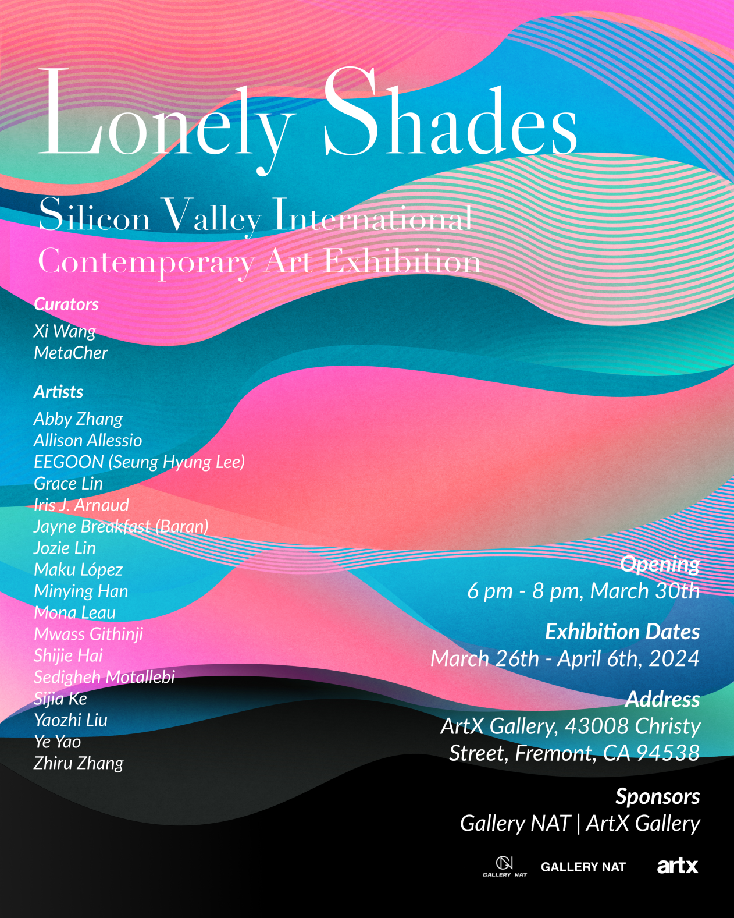
Introduction to the exhibition：
In Silicon Valley, the technological heart of the United States, Gallery NAT and ArtX Gallery have teamed up to create an artistic feast: "Lonely Shades - Silicon Valley International Contemporary Art Exhibition". The exhibition aims to delve into how loneliness, as a universal human experience, reveals its profound social and philosophical significance in artists' creations, as well as its impact on our relationship with ourselves, others, and even the world.

In the wave of digitization and globalization, human societies seem to be more closely connected than ever before. However, information overload and the proliferation of social media have made true human connection increasingly rare, and loneliness has become more prevalent in modern society. By showcasing the works of artists from all over the world, this group exhibition not only reveals the diversity and complexity of loneliness as a universal phenomenon, but also explores the profound impact of loneliness on the psychological and social dimensions of individuals.

Whether in painting, sculpture, video or installation, the artworks reflect the artists' understanding and feelings of loneliness, isolation, sadness and related psychological states through unique perspectives and languages. These works not only challenge traditional notions of loneliness, but also provoke profound reflections on self-perception, interpersonal relationships and social connections.

Accompanying the exploration of the theme of loneliness is a vision of building bridges between cultures and ideas. The unique social and cultural context of Silicon Valley, a global center of technology and innovation, provides a rich ground for this artistic exploration. Through the power of art, the curators hope to promote cross-cultural understanding and dialog, reflecting on the impact of technological development, social conflicts, and environmental changes on human social and psychological states, and how people can find and maintain true connection and meaning in this rapidly changing world.

"Lonely Shades - Silicon Valley International Contemporary Art Exhibition" is co-organized by Gallery NAT curatorial team and ArtX Gallery. From a global open call of over 1,000 works, 17 outstanding contemporary artists and their works from the United States, France, Spain, China, South Korea, Kenya, Iran, China-Taiwan, and other countries and regions were selected to be exhibited at ArtX Gallery in the San Francisco Bay Area. Exhibition curators Xi Wang and MetaCher are committed to exploring the universal and complex theme of loneliness across cultural and geographic boundaries with artists and audiences worldwide. In this artistic journey, it is expected that each participant will discover the beauty and meaning in the works of art, and it is hoped that this exhibition will inspire deeper reflection on human nature, society, and the world we live in together. In this era of challenges and possibilities, through the power of art, we will search together for connection, understanding and hope.

Exhibition theme
Lonely Shades - Silicon Valley International Contemporary Art Exhibition
Sponsor
Gallery NAT / ArtX Gallery
Curator
Xi Wang / MetaCher
Opening Time
March 30, 2024 18:00-20:00
Exhibition time
March 26-April 6, 2024
Exhibition Gallery: ArtX Gallery
Exhibition address
ArtX Gallery, 43008 Christy street, Fremont, CA94538 United States

Exhibition Artist：
Abby Zhang / Allison Allessio / EEGOON (Seung Hyung Lee) / Grace Lin / Iris J. Arnaud / Jayne Breakfast (Baran) / Jozie Lin / Maku López / Minying Han / Mona Leau / Mwass Githinji / Shijie Hai /Sedigheh Motallebi / Sijia Ke / Ye Yao / Zhiru Zhang /Yaozhi Liu

