Women in Art Fair returns with a challenging programme for London Frieze Week:

“We believe that radical innovation is the only way to disrupt the current broken art world model”.

Women in Art Fair | 9-12 October 2024
Mall Galleries, The Mall, London SW1
womeninartfair.com |@womeninartfair

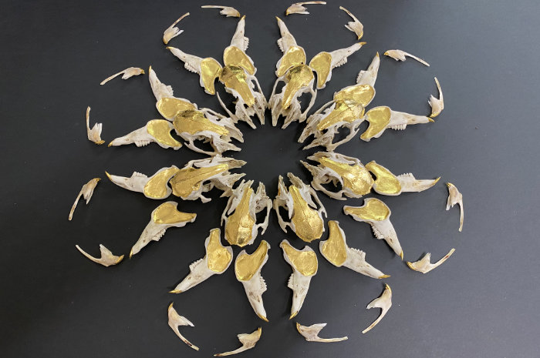
Elpida Hadzi Vasileva, Looking Internally 2021, rabbit bones, gold leaf

Women in Art Fair returns to the Mall Galleries this year to provide a prominent platform for women artists, gallerists and curators during Frieze, London’s biggest annual arts week.

“This is not about excluding men,” says fair founder Jacqueline Harvey, “It's about disrupting the established model which isn’t serving us, as it’s failing half of the artistic community: women.”

She continues, “We need radical innovation to addresses the glaring gender imbalance in the industry. We stand for diversity and inclusion in the arts and we’re here not just to encourage dialogue around gender and culture, but fundamentally to change the way art is exhibited.”

Making women’s work visible is where Women in Art Fair’s annual event succeeds. Launched in 2023 with 20 galleries and 200 independent artists showing work, WIAF had over 2000 submissions via an Open Call for inclusion in this year’s Fair, all responding to the theme of the creative process: the challenges and setbacks experienced during the journey to produce a final work of art.

Cynthia Valianti Corbett, a member of the Fair selection committee, is a longstanding supporter of women artists through her eponymous gallery (celebrating 20 years this year), Young Masters Art Prize, incorporating Emerging Women Award and her curatorial platform, Focus on the Female. She says,

“It has been encouraging to see women artists beginning to get more recognition in recent times, building their confidence and bringing more wonderful work to the fore – as has been witnessed by the exceptional quality of work submitted for our Open Call this year. Women in Art Fair is both a powerful initiative - in terms of profile-raising for our exhibitors - and an important moment to celebrate all that women contribute to the art ecosystem.”

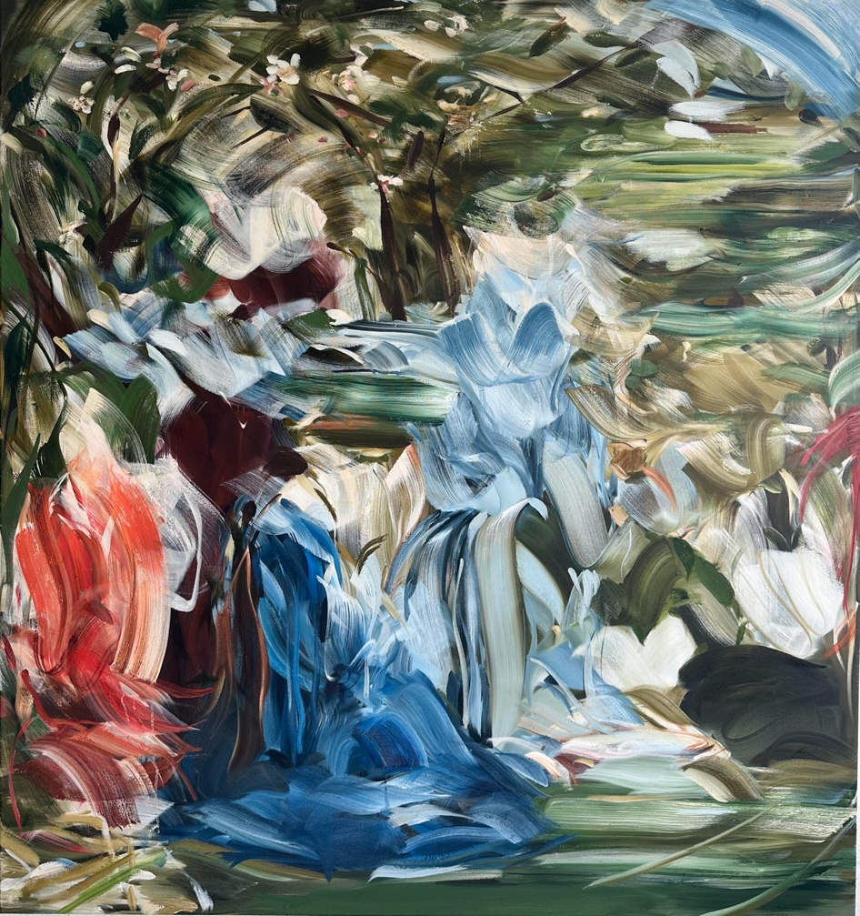
Megan Baker, The Sap Rises in the Spring, 2024 oil on canvas, 145x135cm, showing with Gillian Jason Gallery at WIAF 2024
Women in Art Fair is clear that collaboration with like-minded organisations is needed to help shift the needle on representation of women in the arts. This year they are teaming up with Rise and Repaint (previously known as ArtGirlRising and Repaint History), a social enterprise that has spent the last six years supporting and advocating for women and non-binary artists globally. Working with established museums, galleries and art organizations to help solve the gender gap in the art world, they say:

“Female artists remain drastically underrepresented and our surveys prove that exhibition opportunities are still severely lacking. Despite an increased awareness online, we need real opportunities - like exhibition space for women artists. We are therefore delighted to partner with WIAF to help women artists rise to their rightful position in the art world.”

Isabel Bardawil, a Specialist and Associate Director in Post-War and Contemporary Art at Christie’s, London, agrees that art by women needs more room to be seen. Her auction statistics do show signs of hope:

“We have observed a substantial rise in the number of works by living artists, particularly women, at auction,” she says. Since 2023, there has been an 18% increase in the percentage of lots by living women artists offered at Christie’s. In our most recent 20th/21st Century Evening Sale in London in March, 40% of the lots by living artists were by women.”

It seems that the tide is turning.

-ends-
NOTES TO EDITORS

Listings information

Women in Art Fair
9-12 October 2024
Mall Galleries, The Mall, London SW1Y 5AS
www.womeninartfair.com | @womeninartfairofficial
Public opening hours
Wednesday 9 October 1pm – 5.30pm
Thursday 10 October 10am – 7pm
Friday 11 October 10am – 6pm
Saturday 12 October 10am – 4pm
Tickets: https://womeninartfair.com/tickets/
Events: A number of free talks and receptions will take place during the fair. Please see the website to reserve seats https://womeninartfair.com/events
The WIAF Team
Jacqueline Harvey, Director
WIAF is directed by author, educator, journalist, broadcaster and award-winning businesswoman, Jacqueline Harvey. A graduate of Goldsmiths, University of London, with a degree in Philosophy and Sociology, Jacqueline's extensive career includes working for nine years as Managing Director of Art Strategics, a Mayfair gallery which championed inclusivity and diversity through a successful exhibition, education and international fair programme. She has worked at many art fairs, including START, London Art Fair, Masterpiece, Art Basel and Art Bahrain. In addition to her career in the arts, Jacqueline has written books on health and wellbeing and is regularly interviewed on the BBC and in the national press. She has her own weekly programme on Women's Radio.
Jacqueline Harvey says: "The world has been through incredible changes in recent years and women, as artists, have continued to create and help maintain stability in these volatile times. We need to celebrate the journey we have been on and look at the new paths and opportunities we are going to create for future generations."

Committee:
- Co-founder of iconic gallery Riflemaker, Virginia Damtsa is a well-known art dealer, gallerist, curator and artists' agent.
- Cynthia Valianti Corbett is Director of The Cynthia Corbett Gallery and Founder of The Young Master’s Art Prize.
- Philanthropist and entrepreneur Theresa Roberts, has a leading collection of contemporary Jamaican art and was appointed Jamaica Ambassador/Special Investment Envoy for Culture and Arts in 2023.

Mall Galleries, The Mall, London SW1
Managed by the Federation of British Artists, Mall Galleries is located in the cultural heart of London’s thriving arts and heritage district on The Mall, between Buckingham Palace and Trafalgar Square. Behind the elegant facade is over 450sqm of fully equipped exhibition space of unparalleled scale for its location. For over fifty years, it has served as a national focal point for figurative art; hosting exhibitions by eminent Royal art societies and welcoming a range of activities from art fairs, auctions, solo, group exhibitions and more. mallgalleries.org.uk

Mall Galleries
The Mall, London SW1
mallgalleries.org.uk
Managed by the Federation of British Artists, Mall Galleries is located in the cultural heart of London’s thriving arts and heritage district on The Mall, between Buckingham Palace and Trafalgar Square. Behind the elegant facade is over 450sqm of fully equipped exhibition space of unparalleled scale for its location. For over 50 years, it has served as a national focal point for figurative art; hosting exhibitions by eminent Royal art societies and welcoming a range of activities from art fairs, auctions, solo, group exhibitions and more.
Media information:
Press Contacts: Theresa Simon theresa@theresasimon.com +44 (0)7976 766221
VIP and Press View: Weds 9 October 10am -12noon (guest list or ticket holders)
Launch Reception: Weds 9 October 6pm-9pm (guest list or ticket holders)
Press accreditation: email press@womeninartfair.com or contact Theresa Simon

