The Light of Freedom
Minying Han's Silicon Valley Photography Exhibition
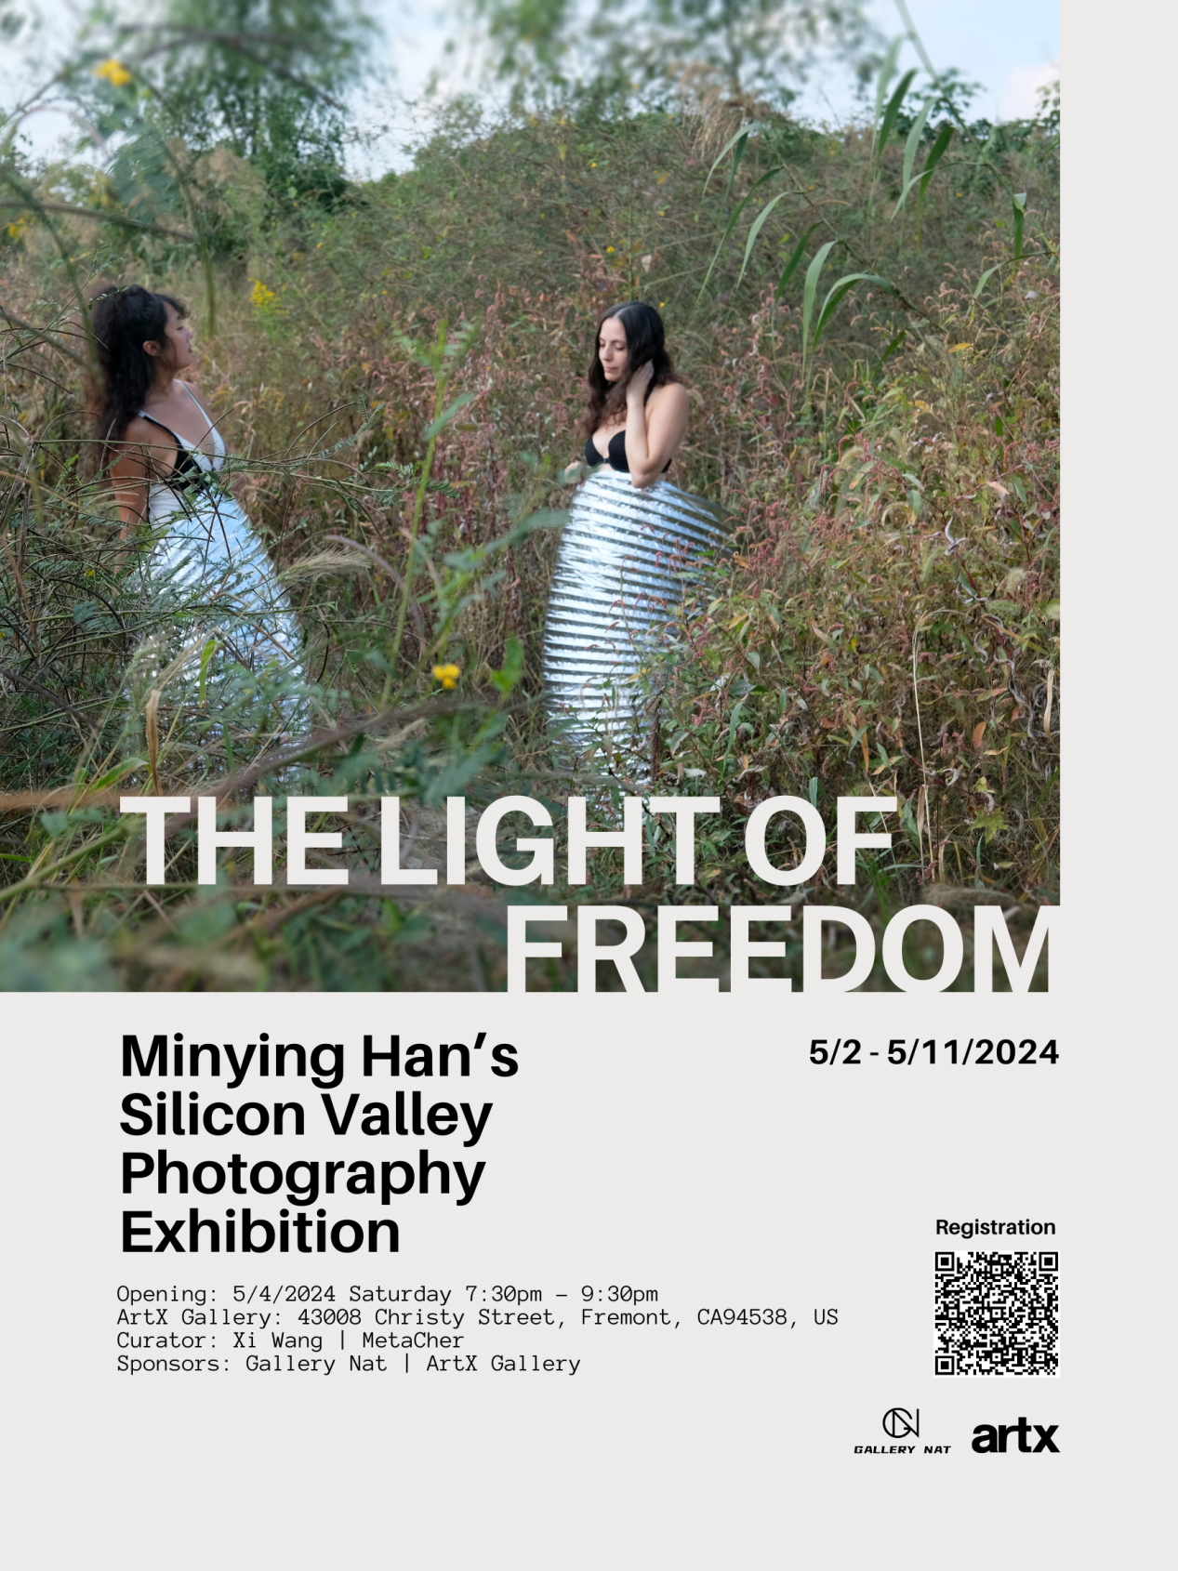

Exhibition Preface:

Contemporary photography is not merely a showcase of technical prowess; it's a reflection and contemplation of present-day societal culture. In Minying Han's artworks, we witness a strong, liberating radiance that permeates every corner of society, illuminating the position and value of new women in contemporary society.

The series "Whispers of Autumn," "Breath," "Freedom," and "Crowded Paradise" are more than just images; they represent a profound exploration of new female identity. Within these works, we witness the multifaceted expression of women as an ideology, a value system, a revolutionary strategy, and a way of life. They showcase the power of societal values and intellectual liberation, embodying confidence, sunlight, progress, literacy, self-discipline, independence, and remarkable abilities of self-awareness and self-analysis. These women have made significant contributions to society, striving for the realization of freedom, equality, confidence, strength, and spiritual empowerment.

With her unique perspective and exquisite photographic skills, Minying Han captures the inner worlds of these new women and their various expressions in society. Under her lens, women are no longer passive or defined; they are vibrant and empowered individuals. They courageously pursue their dreams, take responsibility for their lives, and positively influence society as a whole.

This exhibition will showcase Minying Han's latest achievements in the field of photographic art, presenting viewers with a visual feast celebrating the power of contemporary women. We sincerely invite you to join us and experience the freedom of light, as well as the strength and charm of new women.

The exhibition will be held at ArtX Gallery in Silicon Valley, USA, from May 2nd to 11th, 2024. We look forward to your presence!

Exhibition theme
The Light of Freedom
Minying Han's Silicon Valley Photography Exhibition

Sponsors
Gallery NAT / ArtX Gallery

Opening Time
May 04, 2024 7:30pm-9:30pm

Exhibition Date
May 02-11, 2024

Curators
Xi Wang /Metacher

Artist
Minying Han

Exhibition Gallery
ArtX Gallery

Exhibition address
ArtX Gallery, 43008 Christy street, Fremont, CA94538 United States

Exhibition Artworks Display:
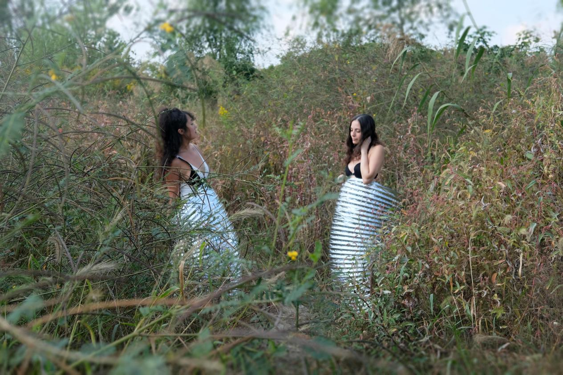
Minying Han "Autumn Whispers - Silhouette" 50×33cmphotography
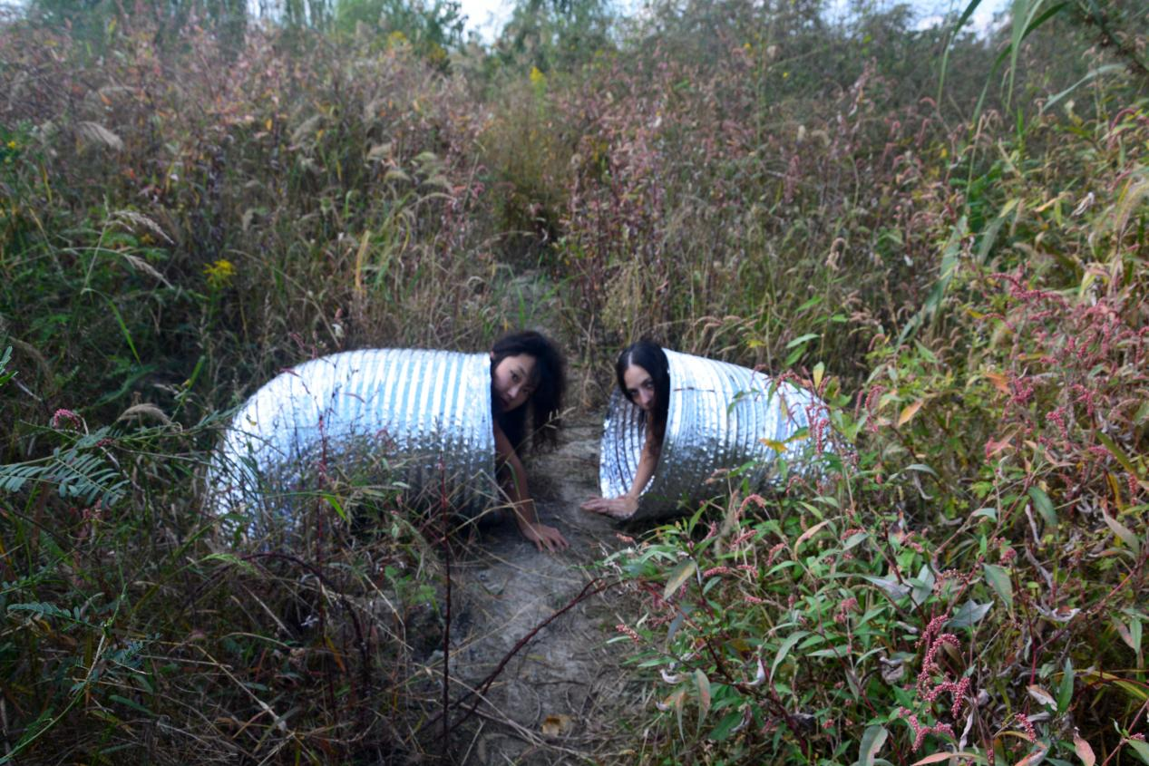
Minying Han "Autumn Whispers - Gaze" 50×33cm photography
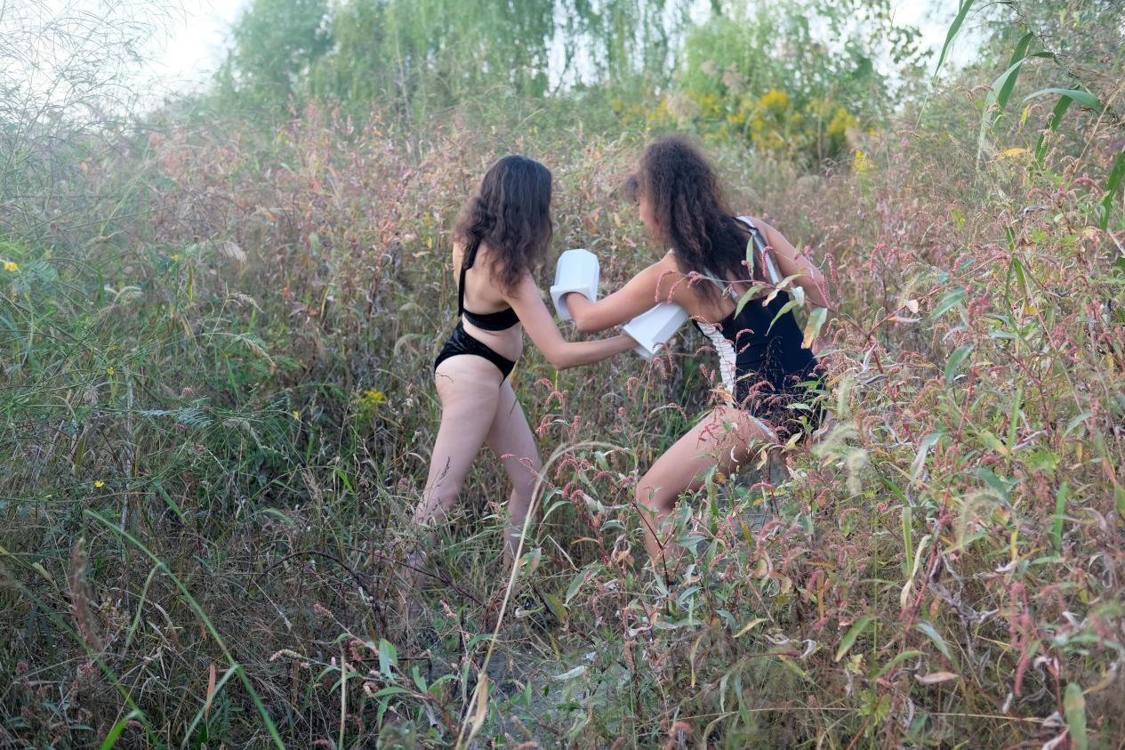
Minying Han "Autumn Whispers - Vitality" 50×33cm photography
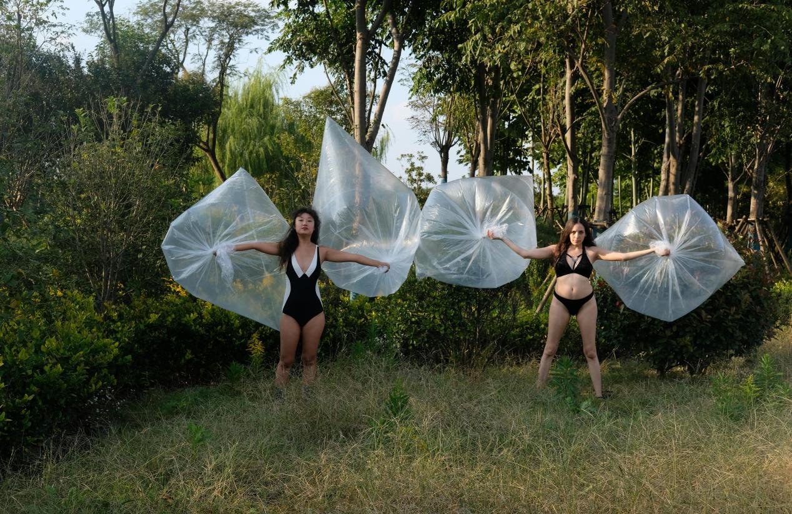
Minying Han "Wind Blowing Pinellia" 100×66cm photography
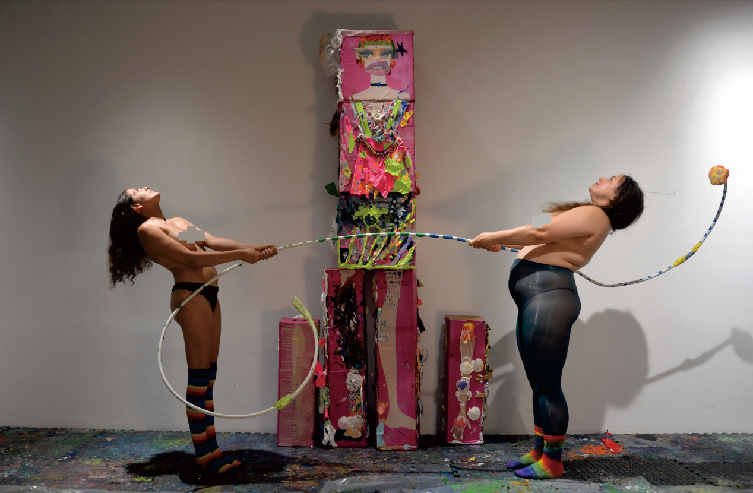
Minying Han "The Perfect Barbie - Balance" 50×33cm photography

